Lab - Configure Folder Redirection in Windows Server 2012 R2

In this lab, students will learn to redirect a user’s My Documents and Desktop folder to a file server for backup and high availability.

Overview

Folder Redirection is used to manage data effectively to back up data. By redirecting folders, you can ensure user access to data regardless of the computers from which a user logs in.

More importantly, if a user’s PC becomes inoperable and their data cannot be recovered, their My Documents and Desktop folders will be safely backed up to a remote location. Using a GPO to manage a user’s data ensures when the user's machine is rebuilt or the user is moved to another machine, they will have access to their data regardless.

Hardware and Software Requirements

1. One virtual machine running Server 2012 r2 full install
2. One Virtual machine running Windows 7, 8.1 or 10 Professional or better
3. One shared folder

**Configuring Folder Direction**

We first need to create a shared folder at the root of our C:\ on our full install of Server 2012 r2.

1. Click on the Windows start button. 
2. Open the tile marked This PC. 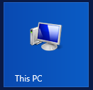



1. Open the drive marked Local Disk (C:)
2. Right-click on any free space of the white windowpane. From the context menu, choose New>Folder.

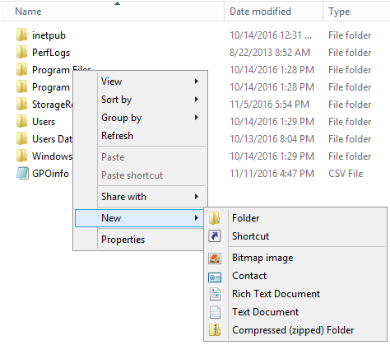

1. Name folder UserData. Right-click on the new folder and choose properties. Open the sharing tab and click on the button marked share.

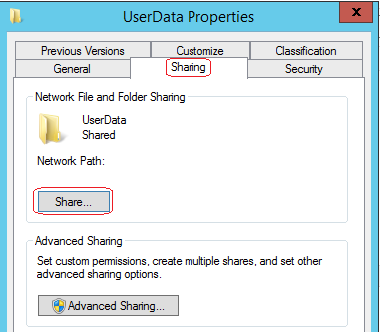

1. In the **Choose people on your network to share with** window, type in **Everyone**. Click the **Add** button and then click share.

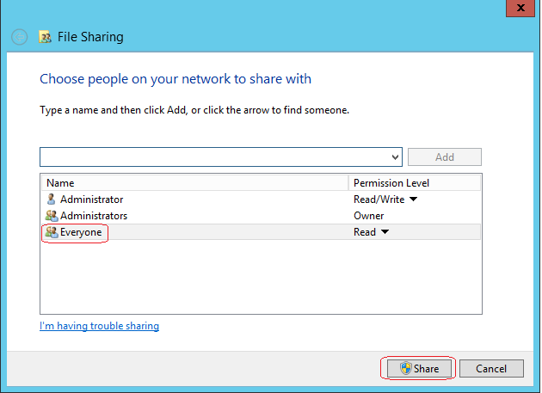

1. Take note of the UNC path \\DC1\UserData. This the path the GPO will use to redirect user’s data. As each users data is redirected and backed up to this share, a new users folder will be created by adding a system variable to the front of the UNC of %username%.

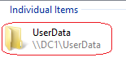

I prefer that everyone in the domain be subject to this GPO, so I configure the GPO Default Domain Policy.

We’ve seen how we create a new GPO using the GPMC but here’s the thing about Group Policy, each time a user logs on and off the network, each GPO must be applied and removed. The more GPO’s, the longer it takes to complete the log on and log off sequence.

The other issue with Group Policy is when a GPO is applied, the machine must run through each setting regardless if the user needs but one small part of the GPO. It makes sense if the GPO is designed to affect Everyone, we use as the existing Default Domain Policy. This isn’t always possible when we use a GPO for specific groups or users, but in this case, we can use the use it.

From Administrative Tools, open **Group Policy Management**

Under your domain name, under Group Policy Objects, find the Default Domain Policy.

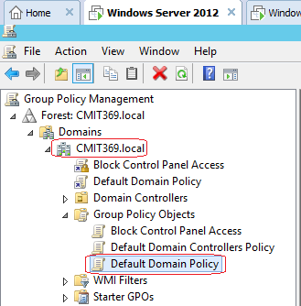

Rick click on the Default Domain Policy and select **Edit**.

This brings up the **Group Policy Management Editor**. Open **Users Configuration**. Open **Windows Settings** and finally, **Folder Redirection**. We will be configuring both the Documents and Desktop for redirections.

**Warning! Be very careful with this policy! If your domain has remotes sites using the Default Domain Policy, do not enable Folder Redirection at this level unless you can filter the remote site users from the effects.**

**For instance, if the DC is in Tucson and you have users in Sierra Vista, you do not want the users in Sierra Vita having their data redirected to your server in Tucson.**

**Secondly, you see a lot of folders that can be redirected. Be very careful on what you choose! Remind users any data left on their desktop or documents will be backed up to the server.**

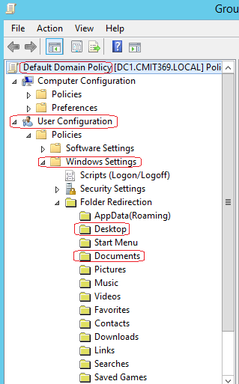

Right-click on the Desktop folder and select properties.

In the Document Properties dialog box, on the Target tab, next to Setting, click the drop-down arrow, and then select **Basic – Redirect everyone’s folder to the same location**…

Ensure the Target folder location box is set to **Create a folder for each user under the root path…**

In the Root Path box, type \\DC1\Userdata\%username% (your UNC path may differ) and then click OK.

The %username% is a system variable and tells the policy to create a folder in the UserData folder using the user's profile name.

The Root Path must be a UNC path to be treated as a network share. You **cannot** use C:\UserData. The root path must be a network share!

Click on the settings tab. If the settings are configured correctly, you can recover if needed. For instance, if you tried to redirect the users AppData, you would have discovered this was a huge mistake, and you need to remove the folder Redirection for AppData. If you move the Appdata and you try to come back after your mistake, you will not be able to select the option to move the user’s data back to its user’s profile. You need to do it now! Always err on the side of caution.

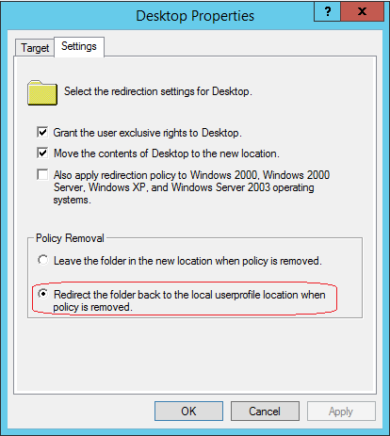

Click OK

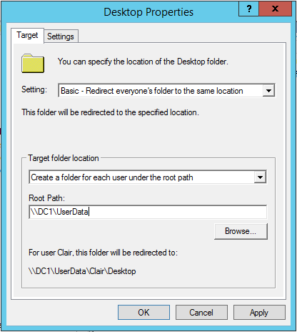

Say Yes to the warning. Click Ok.

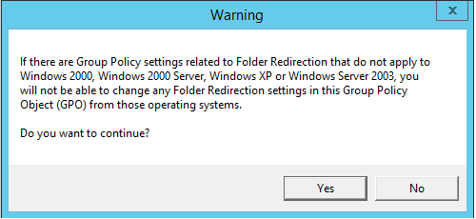

**Repeat the steps for folder redirection for the Documents folder.**

The user will notice nothing but their data is being pushed out to a file server where it is now part of the nightly incremental backup. If a user deletes an important Excel spreadsheet from their Desktop, you can use the backup to recover the file (hopefully).

Next, to test our new GPO and our folder redirection settings, log into your Windows 7 client. Launch a command prompt and at the prompt type: **gpupdate /force**

You may receive the following warning. Read it carefully! It tells you the GPO settings for folder direction will take effect after you restart. Say yes to prompt to restart.

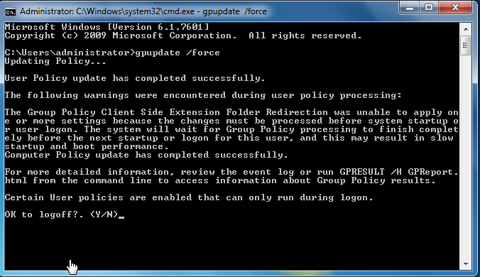

When the client reboots, login and in the taskbar, open your Windows Explorer folder.



Right-click on Documents and select properties. Check out the path for the Documents folder. Say OK.

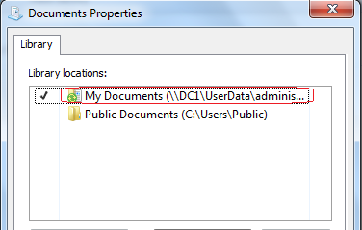

Open the Documents library. Right anywhere in the empty right window pane and select **new>folder**. Name the folder “**Test**”

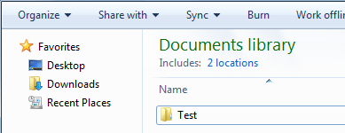

Return to your server. Open the C:\ drive and find the newly created share called UserData we created earlier in the lab. Find the newly created **Administrator** folder and inside find the **Documents** and **Desktop** folders. Open the **Documents** folder to see your newly created **Test** folder.

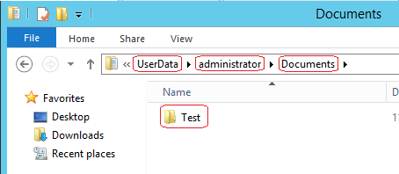

**Summary**

After I implement any GPO, I wait to see what the effects are for users. If I don’t hear anything for the first 3 or 4 days, I can assume the GPO is good to go. Remember to enable the “get out of jail free” in the settings for folder redirection. If you need to undo the GPO, you do not want the user's data sitting on your file server.

I have a set number of GPO’s I roll out across a client’s domain. Folder direction for sure and the mapping of the batch file. The batch file I always roll out is for syncing all the nodes on the network with the DC which I configure as the network time server. This will all be explained in the next lab.

End of the lab!